**CIS 400 Final Project**

**Steam API for game and friend recommendation**

**Group Members**: Zijian Chen, Xueming Feng, Honghao Zeng, Zhongming Yao, Chengjun Wu, Lu Liu.

**Objectives and Background:**

Steam is a gaming platform that Valve company developed for users to purchase and play games. It is the most popular gaming platform in the world and all the other third-party developers, gaming companies would like to put their games on its store.

All of our team members are huge fan of steam games, so we use steam almost every day. Though steam already has lots of community features like friends lists and game groups, we found that it still need more functionalities for users’ convenience. Therefore, our Project tries to implement more practical and interesting features by using Steamworks, which is the steam application programming interface (API) for us to integrate and develop new functions into our project.

**Features:**

1. Analyze user’s game time
2. Analyze user’s gaming category
3. Analyze user’s social network
4. Friend recommendation
5. Game recommendation
6. Game reviews
7. Create charts

**Basic Languages and Tools:**

HTML, JavaScript, CSS, VIS.js, Graph.js

**Homepage:**

From the home page of our website ny.kuroa.me, this website page enables the system to display the title of this webpage. “Home Page”. Also, there is a navigation list on the left top corner indicating all the five functions of our website. The five functions are: Game suggestion, Friend recommendation, Check game time, Graph, and Check Game review. And the user can click on each function name to be navigated to the webpage relating to that function. I will explain more about each function below.



**Game Suggestion:**

For the Game Suggestion function, the users can click on the button of “Game Suggestion” in the navigation list on the home page of the website and it will direct the user to access the Game suggestion page. This website page enables the system to display the website title “Game Suggestion Page”, a text field box that allow the user to input the Steam User Identity Number users are interested in, a dropdown menu that will display the channel of the games and a button which leads the users to the game suggestion result.

In the text field box, it only allows the user to input the proper Steam ID. If the webpage user input a string that does not exist in the Steam database, there would be no searching result display on the website page after clicking the “go” button. In the dropdown menu, there are five channels that include “New and Trending”, “Top Selling”, “What’s Popular” and “Upcoming”; and software users would be able to easily choose the channel they want to search in the dropdown menu by click the channel title. The “go” button can generate the search result.

After click on the “go” button, the search result will be listed below the “go” button in different game categories. The most often played game categories will be listed such as Multiplayer, Action, Co-op, and Difficult. Under each category, the games will be listed with the pictures, and the user can scroll right to see more options. By clicking on the game picture, the user can easily go to the store page of this game get more information of the game through Steam.

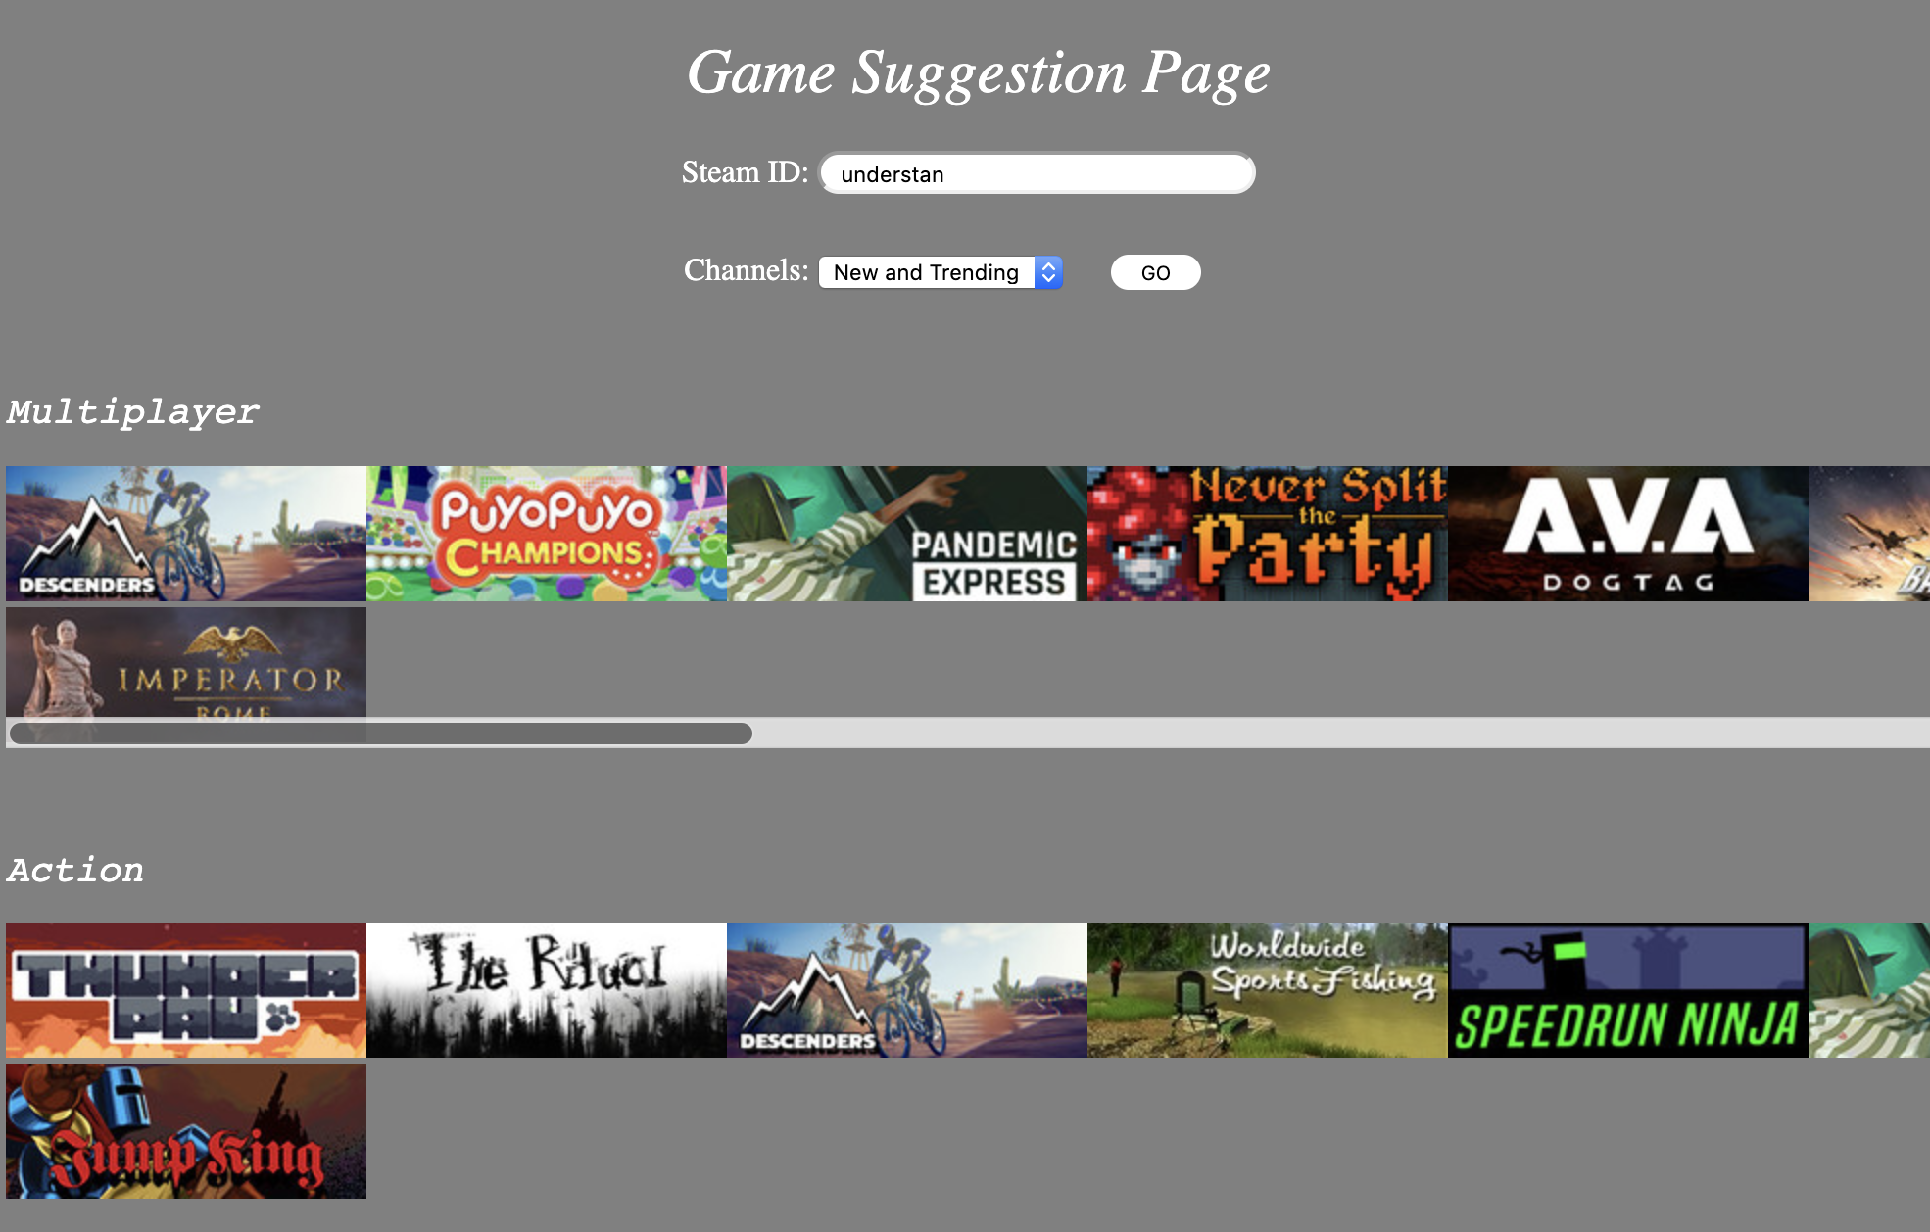

This function can help the users easily find the games they most possibly like according to the game they played. And they can easily find the best one by selecting in different categories.

In next section, we will take a deep look into the code about how it actually works and gets the result.

fetch_popular_bytag.js

// All comments will describe the code on top of it

|  |
| --- |
| function fetch_popular_bytag(tag,channel="TopSellersRows"){  //This defined the name of the function, it will take in 2 variables. The first variable will be the tag of the games we want to fetch. The second variable decide which channel will the API call fetch the game from. There are total of four channels in the trending tag: “New and Trending”, “Top Selling”, “What’s Popular”, and “Upcoming”. The default had been set to “Top Selling”. So all the result got by this call will be return from that row. |
| return new Promise((r,j) => {  // This define a new Promise and return it. The reason for this is for HTML to load faster for user. When the webpage load to this part, without the promise, the browser will wait for the API call to return, which usually takes a rather long time. The promise allows other element on the webpage to load first, then when the API call got the answer, it can update the webpage to let the user see the result. |
| var xhr = new XMLHttpRequest();  // This defines a new raw XML Http Request which will then be modified to fit our use case, and then send to steam server. |
| xhr.open('GET', `http://store.kra.moe/tags/en/${tag}`);  // This defined that this http request’s type is ‘GET’, which is usually used to get data from server. In the variable, we can see that the destination address is not steam server address. This is because cross site protection, more details can be read in the server proxy part. In short, that address will redirect the request to the steam store server. At the end of the address, the variable ‘tag’ was appended to get the information about that specific tag. |
| xhr.setRequestHeader('Accept-Language','en-US');  // This line is optional in most systems. It defines the language the requester want to be US English. Without this header, the language will be the same with the system language. This line was added in case the user is using a system in languages other than English. |
| xhr.send();  // This sends out the http request we just constructed. The reason channel information was not defined in the request is that steam will return the json file that contains information about all four channels. Then the data processing will be complete on the user machine. |
| xhr.onload = function(){  // This line will be called when the client got a reply from the steam server. It will be feed a function to process the information we just got from steam server. |
| if(this.status == 200){  // First, the program will check whether the request has succeed. The status number of 200 means it successfully got the information it requested. Status number other than that means a failure, different number means different reason. |
| var doc = new DOMParser().parseFromString(xhr.response, "text/html");  // In the above lines, we have to create a XML document. When the steam server response, xhr will record the response data in its response field. The DOMParser object provides methods to build XMLDocument objects form XML formatted strings or streams. This time we will use one of its function called parseFromString. It is useful if we have an XML formatted text and we need to handle it as an XML document. The first variable is the xmlString, and the second variable is the media type. In this condition, the xml string will be the response we got from steam, and the format will be html. Now the parsed XML document will be stored into the newly created doc variable. |
| console.log(`http://store.kra.moe/tags/en/${tag}`, doc);  // This command will output the request address we just made, and the response from the steam server. In the code it is mainly used to debug, and understand which API call has succeed. |
| var game_list = [...doc.getElementById(channel).children]  // Since the reply from the steam server had been parsed into XML format. We can now use some of XML functions to get the information we want. The above line will give us the children of the element named “channel”. So in this step, a list of games and their information that in the specified channel had been obtained. |
| .map(el => {  // The map will applied the function it received to every element in the list. This was required because there is a lot of excess information in the list that we do not really need, so we have to pick out the useful information from it. |
| return {appid: el.getAttribute('data-ds-appid'),  // At here, we constructed a small data structure to store and return the data we got. The first piece of data we need is the appid. With appid, we can make other API calls to get the details about the game that are not in the API request we just made. |
| name: el.children[2].children[0].innerText,  // The above line gave us the name of the steam game. The detail syntax of the above line might subject to change, because steam might update their system. The principle is to find the name, and write a getter that can get it all the time. |
| img: el.children[0].children[0].src}  // When we were exploring the data, we found that steam also include the address of the game’s thumbnail. If this line was wrote in the html, the website will fetch the thumbnail from steam server and display it on the screen. So this data is also included. |
| r(game_list);  // The above line means that if the promise has successfully fulfill its duty, it will then return the generated game_list variable that contains all the information we needed to display in the web page. |
| else j('Blyat');  // In contrast, if the promise failed its purpose. It will return the above error message to the main caller of this API call. So the caller can handle this exception. |

If the above API call succeed, the “suggestion.html” will use this data to construct the final webpage.

Data Analysis:



This is the game suggestion of the user: understan, we can first get that this user must spent long time playing multiplayer, action and co-op games, so games recommended are based on those categories. Notice that for all of the three categories, there are some games in common because one game can have multiple categories. Once you click the game you are interested in, you will go to the actually steam store webpage of that game.

**Friend Recommendation:**

For the friend recommendation function, the user can easily access it by clicking the “Friend recommendation” in the navigation list on the home page. This website page enables the system to display the website title “Friends Recommendation”, a text field box that allow the user to input the Steam User Identity Number, and a button that leads the users to the friend recommendation result.

In the text field box, it only allows the user to input the proper Steam ID. If the webpage user input a string that does not exist in the Steam database, there would be no searching result display on the website page after clicking the “Recommend” button.

By entering the Steam User ID and clicking on the “Recommend” button, the user’s profile picture will be displayed below the “Recommend” button. And the user’s friends will start showing up one by one with their profile pictures and Steam user IDs and connecting lines between the user’s profile pictures and the friends profile pictures. The user can easily check all his/her friends on the webpage. Furthermore, the user can click on two of his/her friend’s profile picture to see that friend’s friends, and that friend’s friends will start popping up one by one with their profile pictures and Steam user IDs and connecting edges between the user’s friend’s profile pictures and the friends profile pictures. After the showing these two friends’ profile picture, the user will can see that these two friends may have some common friends. And the common friends will be highlighted to help us notice that..

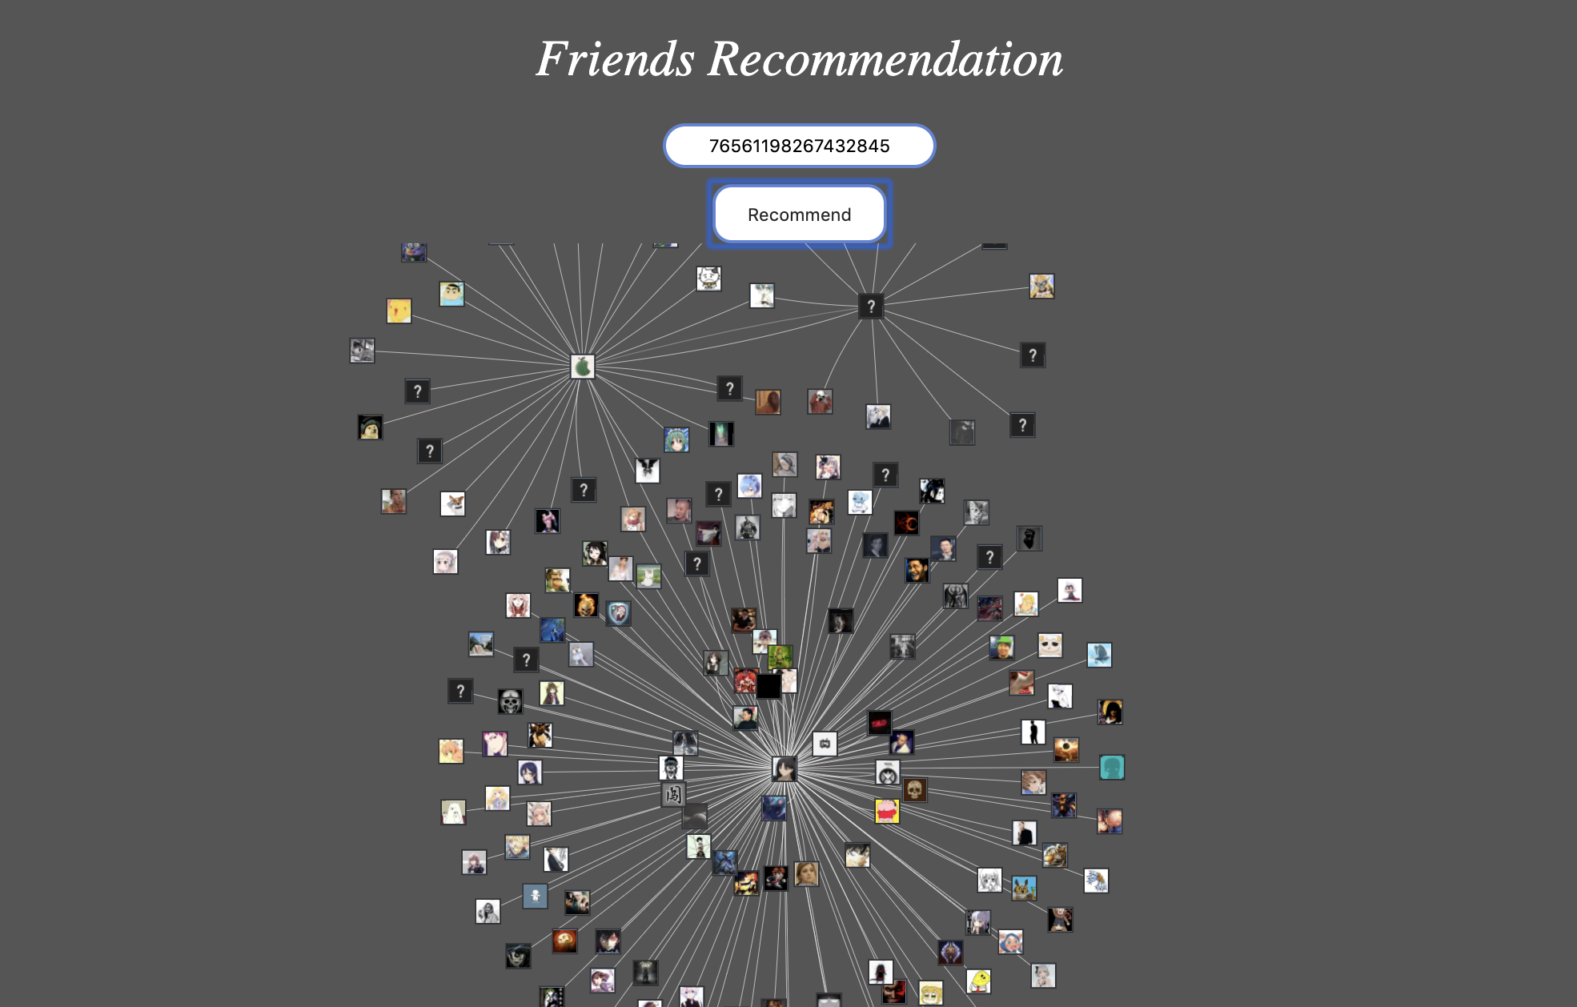

In this friend recommendation function, the user of the webpage can easily check all the friends profile pictures with user IDs and can easily find his/her friends’ friends by clicking on the profile pictures.

In the next part, I will deeply explain some key functions and algorithms in my code.

Since I need to draw the graph of the relationships of the user and his/her friends, I found a javascript tool called vis.js to help me build nodes, edges and graph:

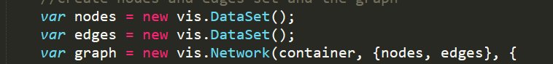

I build two functions for me to easily add nodes and edges:

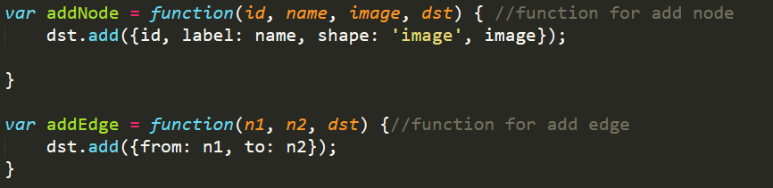

I also create a function called AddNodeEdge() to help me get a user’s all the friends’ id then use for loop to each friends and add them to the nodes set and edges set:

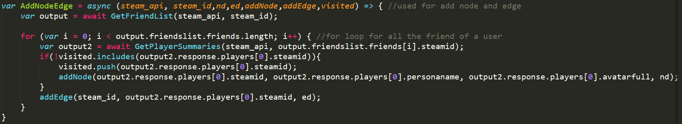

Notice that I create a list called visited [] to store all the user id I already put into the nodes set so that every time I get a new steam id, I will check if it is already in nodes set or not.

To get the friend recommendation, I need to show two of his/her friends relationship graph after the user already click them, so I check if the user click 2 times:

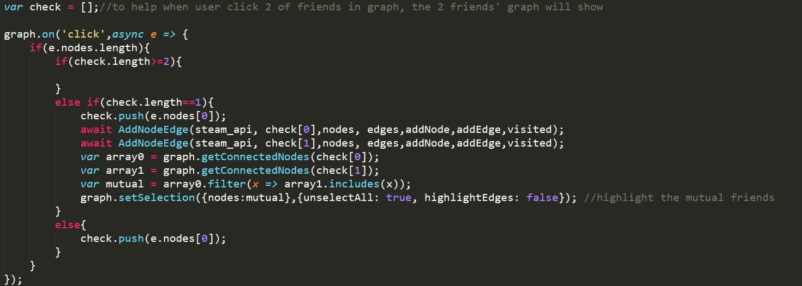

Notice that I have one line of code:



This helps me to highlight any users that are those 2 friends’ common friend.

**Check Game Time:**

For the check game time function, the user can easily access it by clicking the “Check Game Time” in the navigation list on the home page. This website page enables the system to display the website title “Welcome to Our Application”, a text field box that allow the user to input the Steam User Identity Number, and a “View Owned Games” button that leads the users to the result that showing the games that the user has purchased on Steam. And the user can easily check all the time he/she has spent on each game.

In the text field box, it only allows the user to input the proper Steam ID. If the webpage user input a string that does not exist in the Steam database, there would be no searching result display on the website page after clicking the “View Owned Games” button.

After the user enters the Steam ID and click on the “View Owned Games” button, the user will be able to view all the games he/she already got on Steam platform listing below the “View Owned Games’ button. For each game, the user will be able to see the picture and the name for the game. Also, the playing time the user has spent on that game will be listed next to the game name. The user will also be able to see the number of players that are currently playing that game.

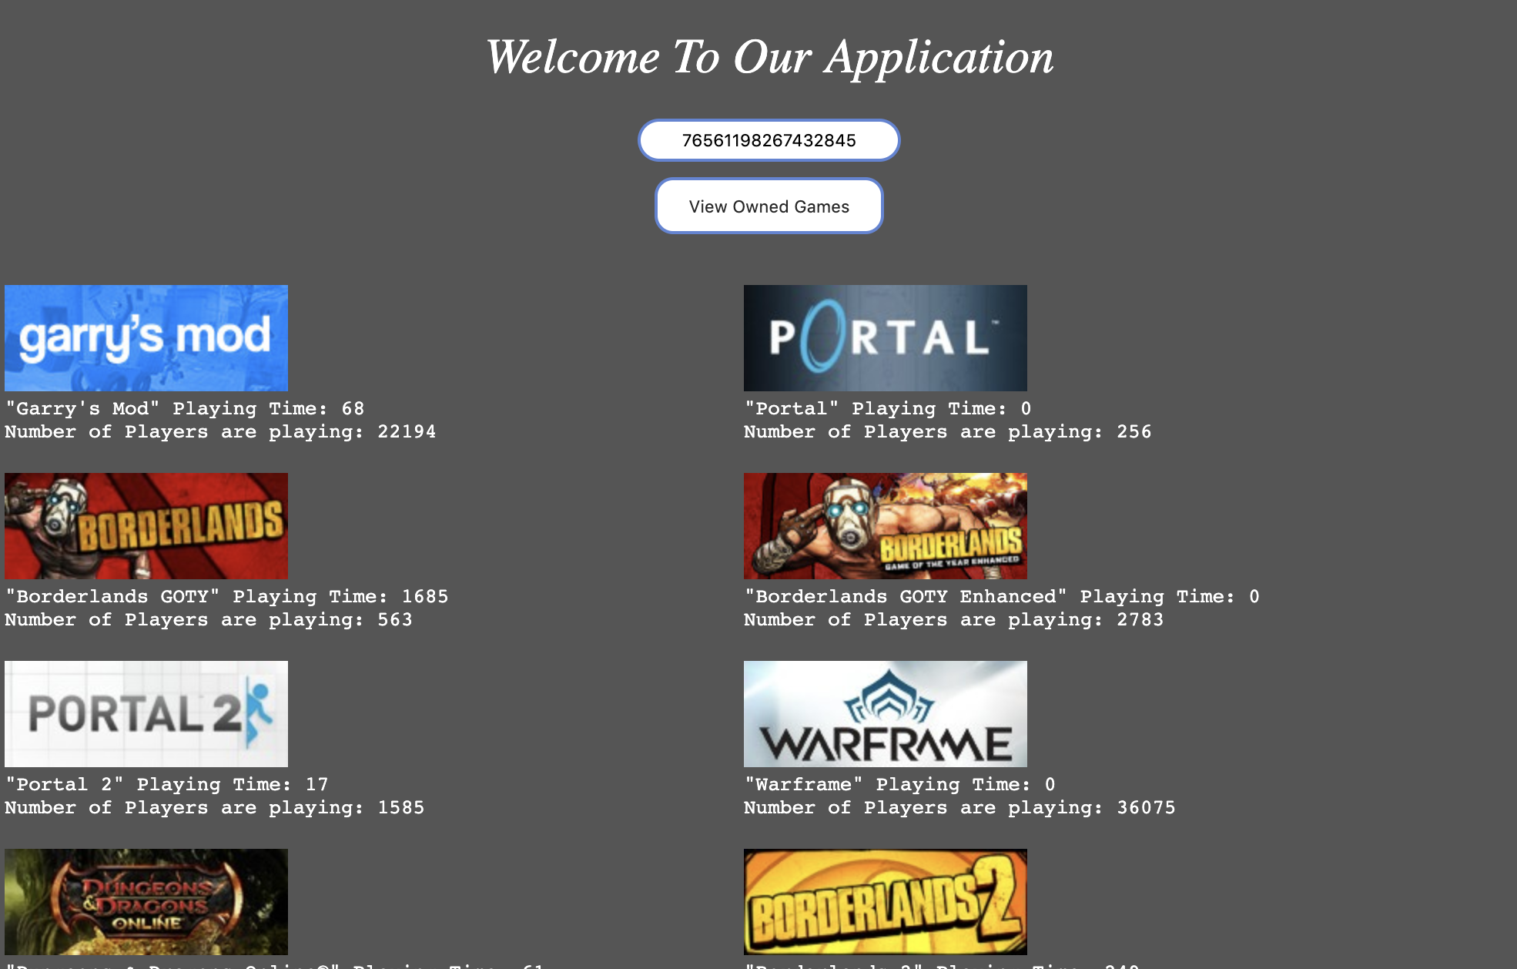

This function will easily help the user to check all the games that he/she owned on Steam and be able to check the time he/she already spent on each specific game he/she has played on Steam.

In the code, I want to use graph to show what each game look like, it takes me some time to figure it out. Luckily I found that api call ‘get user’s profile’ can get the result contain games’ image url, and since the prefix of the url is the same, so I just add the needed information to the back.



**Creating Charts and Graphs Based on Categories of Games**

get_game_tags: This is a function that pulls the game info page and fetches the user define tags from that page. We used XHR to pull the page then create a DOMParser to strip the useful information from that page.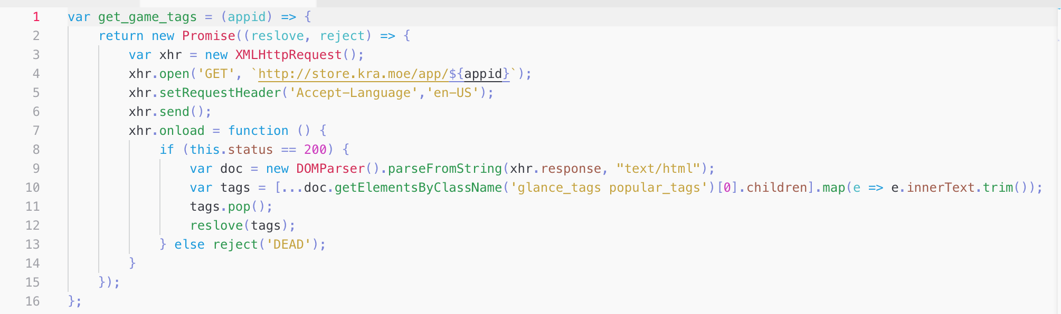

The information we want in an element with "elance_tags popular_tags" class, so we just get that element and map it children elements to text, to get a list of user-defined tags. The last element, however, is a "+" sign, so we call Array.pop() to remove that element from the tags array.

username_reslove: username_resolve is a utility to resolve the user's profile URL (aka unique username), to SteamID64. It calls ResolveVanityURL and returns the resulting SteamID64 if success. In the case of username resolution failed, the original string passes in as parameter will be returned. This provides an easier coding style since we can pass in SteamID64 to it, which will lead to a resolution failure, and the original SteamID64 we passed in will be returned to us.

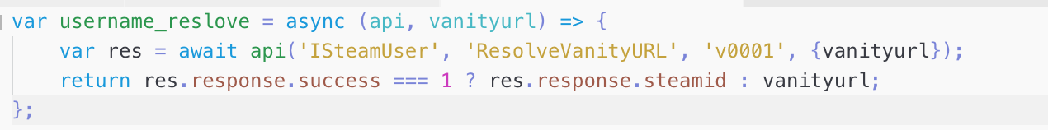

Tools:

user-tags-graph:

Two graphs were both created with graph.js. The graph.js is an easy to use Javascript chart library for browsers. It is open source, HTLM5-based, responsive, and support a vast range of different graph type.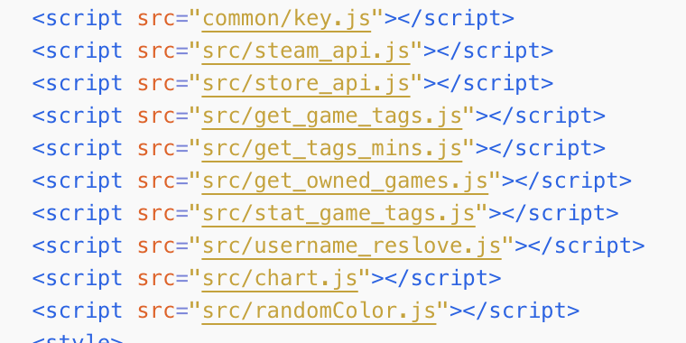

The following components are imported to aid the charting. steam_api provided the base for other components (username_reslove and stat_game_tags). The other components do what you expected to do.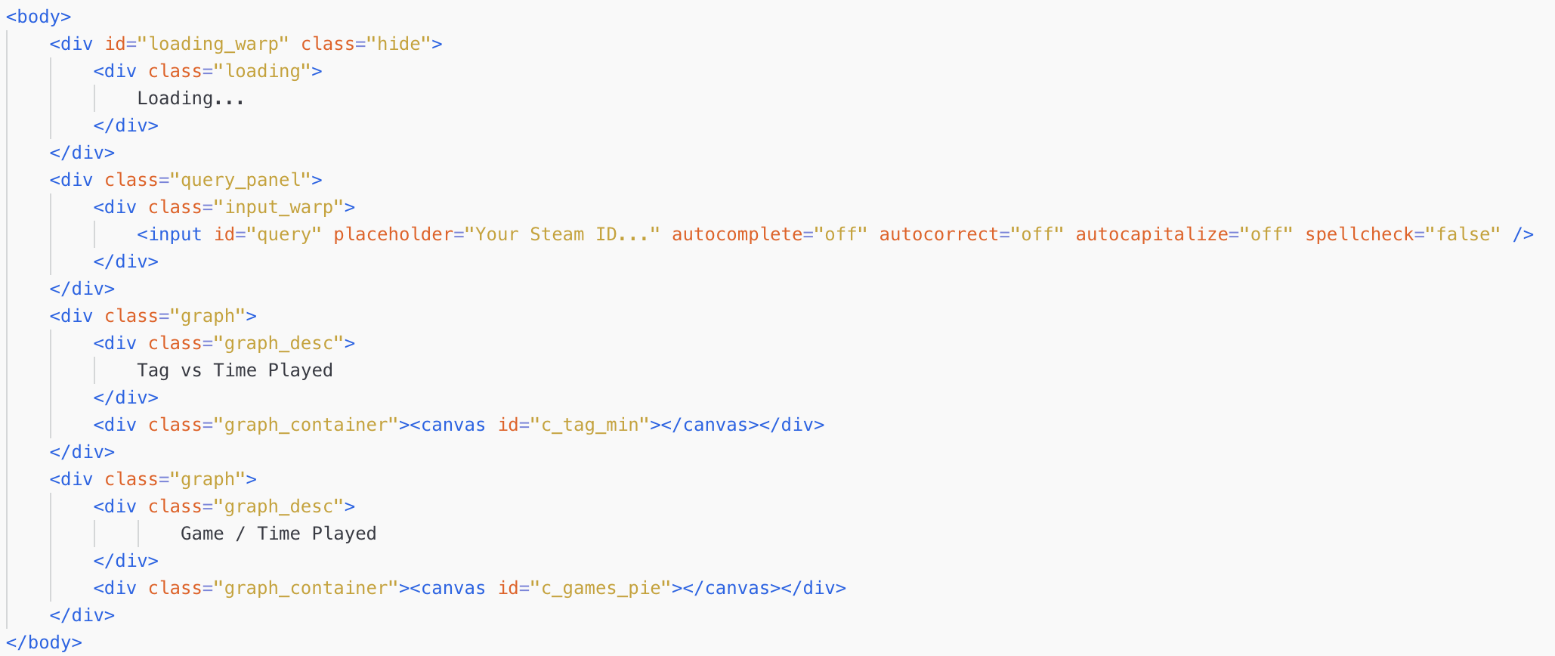

The body part of this tool is simple. We got the Loading mask that covers the entire page that will show when the tool is fetching data from API. The mask element has a "hide" class by default, which set "display: none;" to it so it won't get in the way when the tool loads.

Then we have the query panel that prompt user for a username or SteamID or username and containers for two graphs.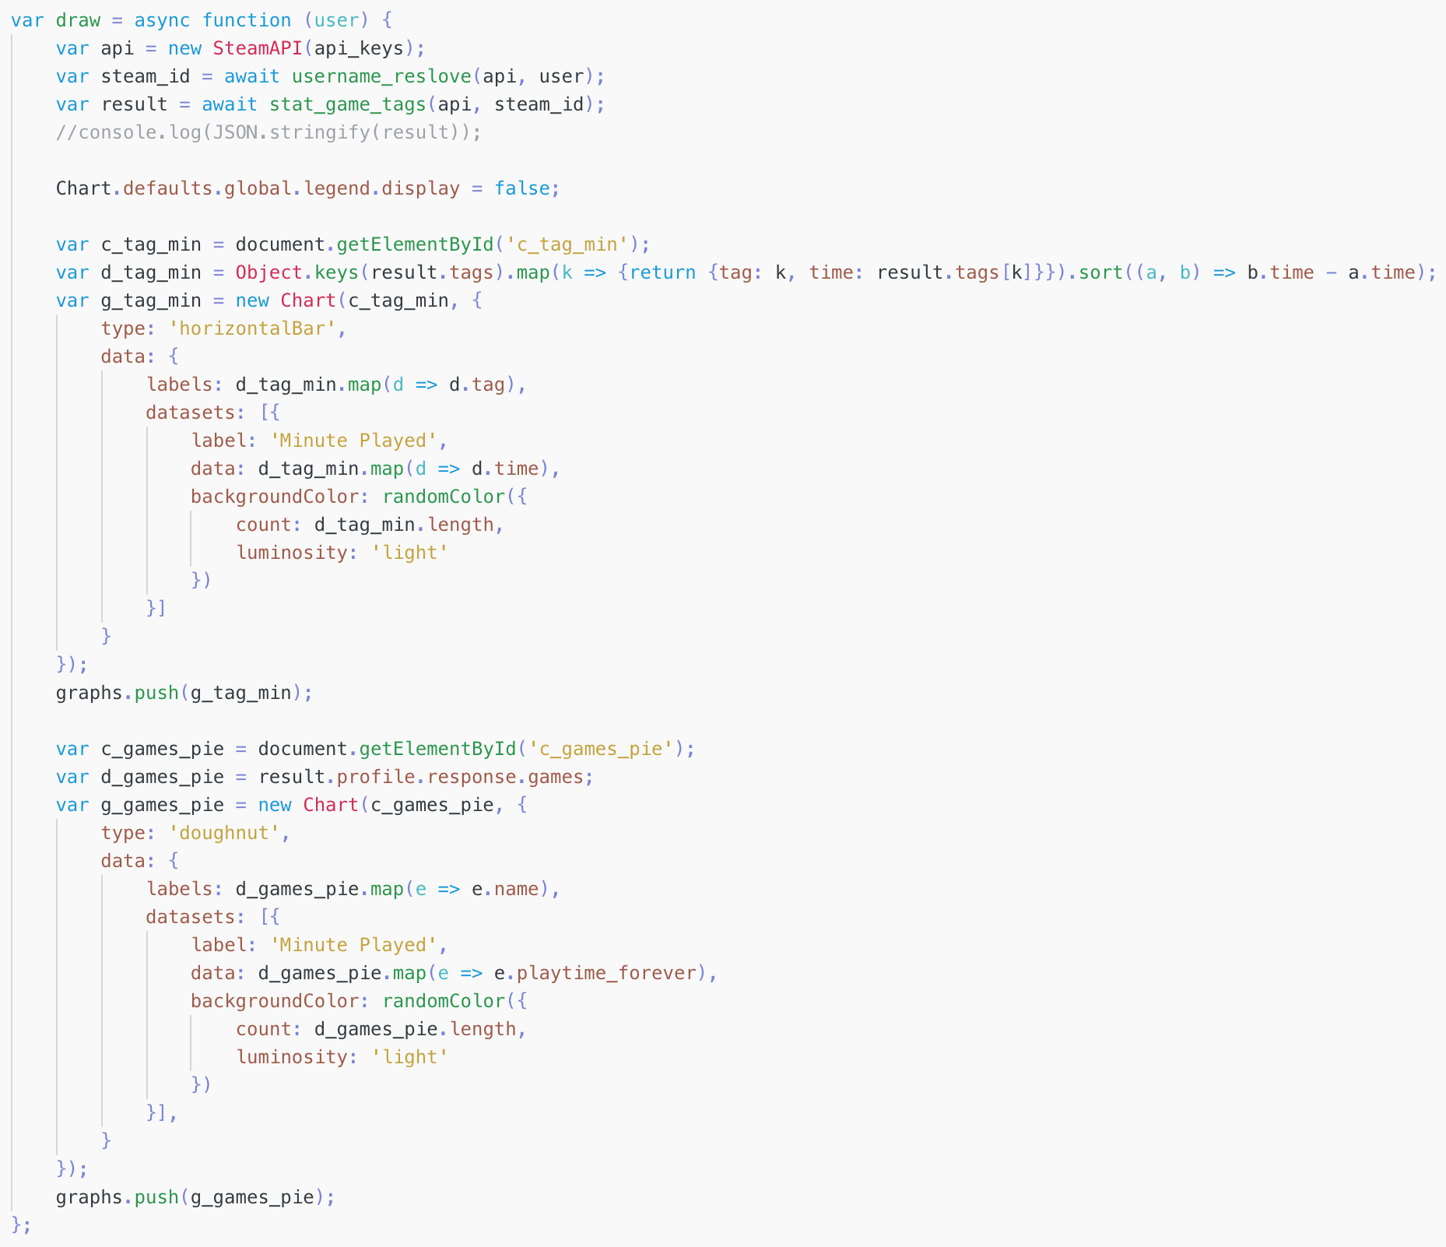

The core logic is contained within the draw function. Draw function takes a username/SteamID as the argument and will try to resolve that to SteamID. Then, we got the tag vs time played graph.

This long line transforms the respond from API into a sorted array of object with the format of "{tag: tagname, time: time}" format. And then the next few lines tell graph.js to actually draw the graph and put it into our container. In the next graph, we do the similar thing, except this time we don't need to change anything from the API respond since the API respond is already in our desired format.

**Game Review Functionality:**

The game review functionality enables user to search a game for its review stats along with the most recent twenty player reviews about the game by either Application ID or Application Name.

There are two ways to search for game reviews, by Application ID or Application Name. Each Application Name corresponds to an Application ID. The game review information is stored with the Application ID in Steam Database that it is not possible to fetch data from the database by Application Name directly. However, users are more aware of Application Name as it is most common identity for a specific game, but not everyone knows the corresponding Application ID for a game. Therefore, we implemented another function to convert the Application Name to the corresponding ID, and use the ID to search for game reviews. In this way, user doesn’t have to know the Application ID in order to search for game reviews.

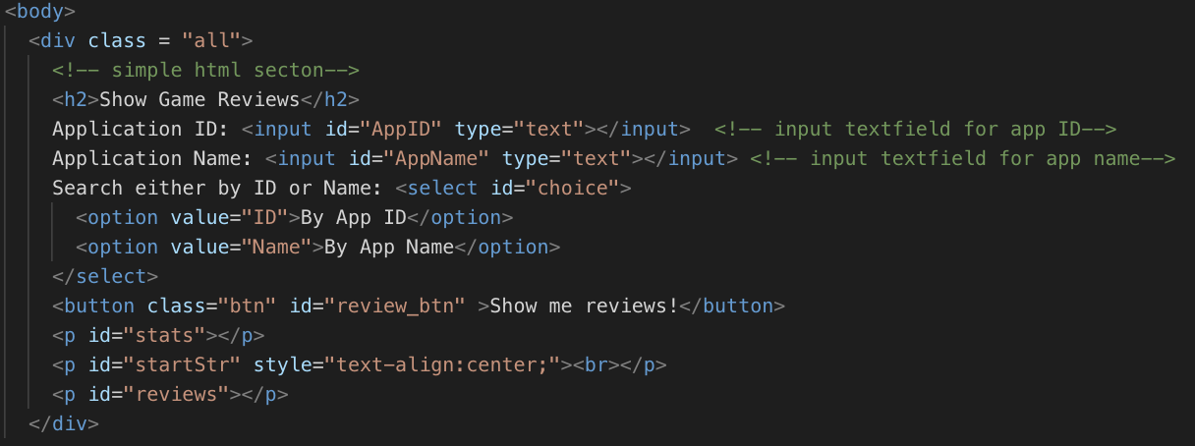

For instance, if the user types in ‘730’ in the Application ID text field, and clicks on ‘Show me review!” button.

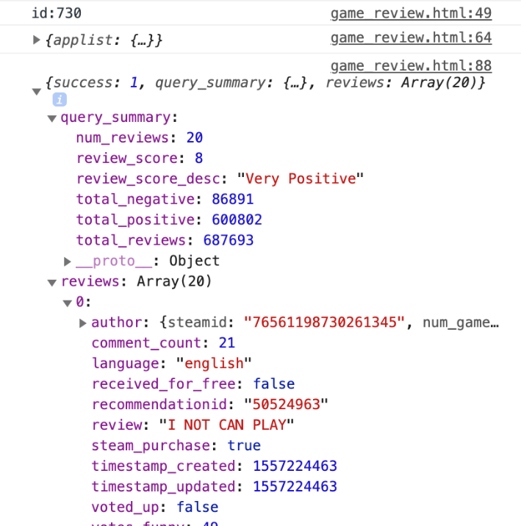

It returns an object which contains all the information about the game we searched in JSON format. The next thing we need to do is to classify the object data to different sections and do a little analysis to show on the webpage.

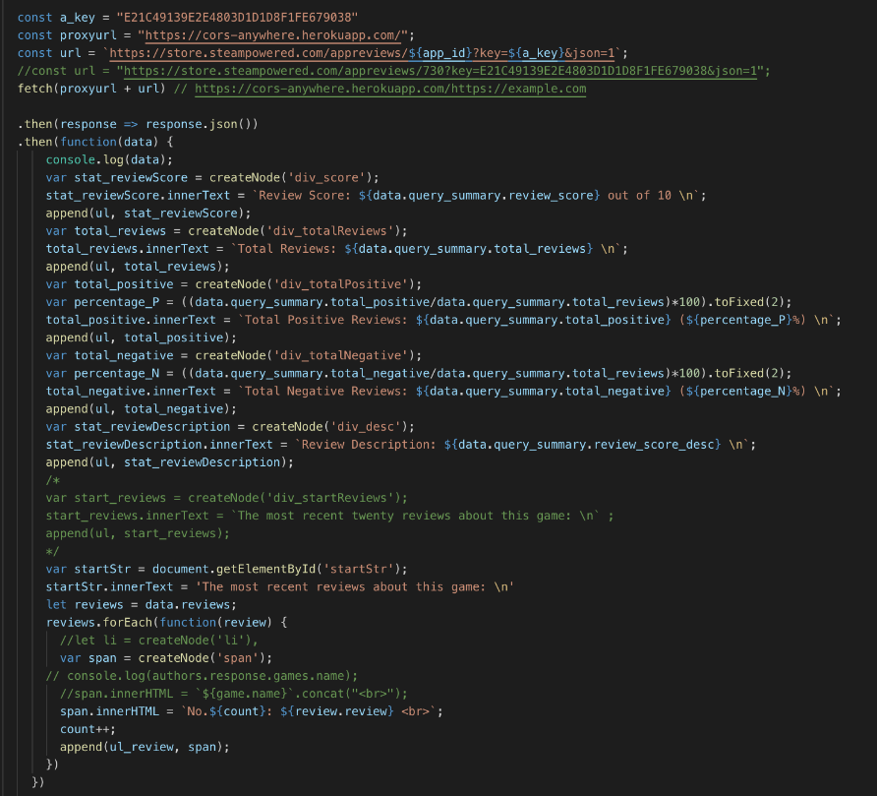

After the program processing all the commands and operations, it will return the wanted data on the webpage as the following images.

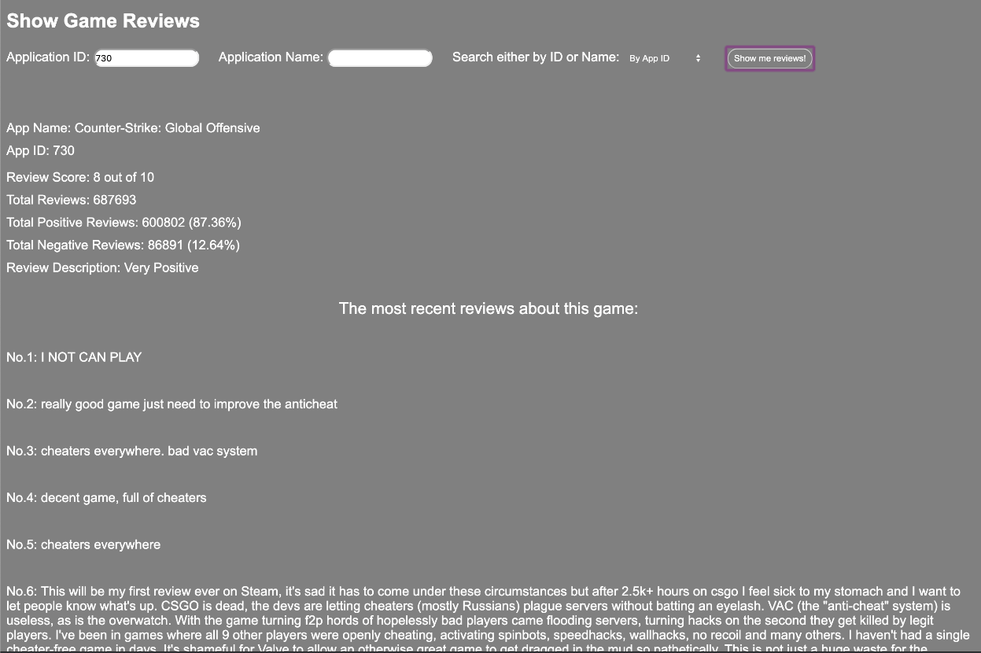

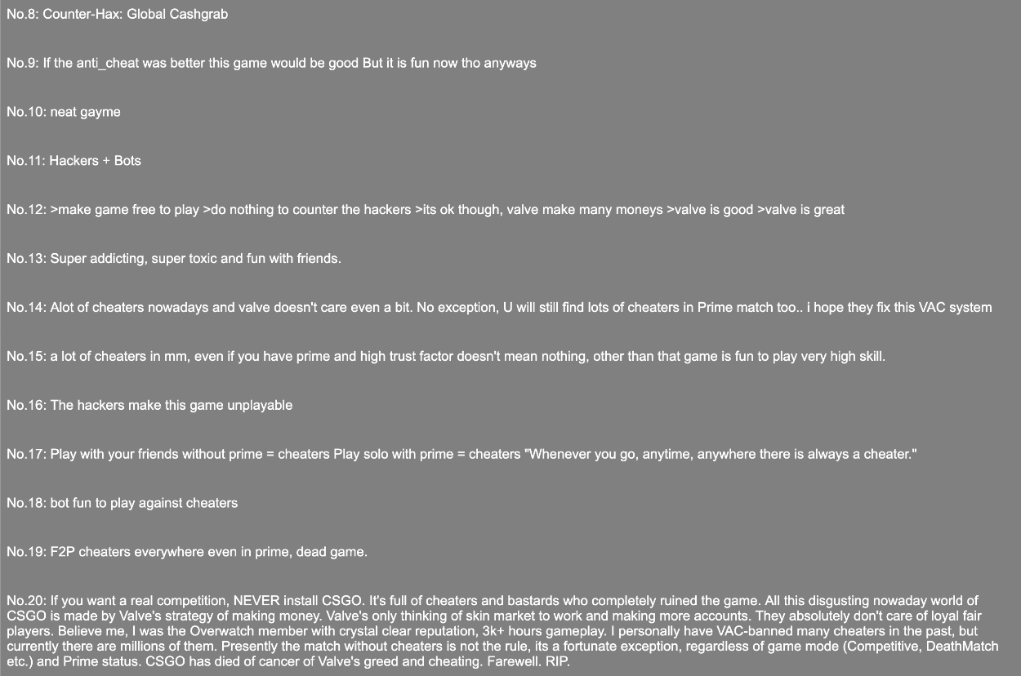

Note here that Steam only allows to fetch twenty reviews at a time, therefore we have a make a loop to fetch more reviews if the user wants to see more reviews.

As we said above that user can also types in the Application Name to search for reviews. In this method, we need to add one more step, converting the Application Name to Application ID, before fetching data from Steam Database.

By achieving this goal, we firstly fetching data of all the pairs of Application Name and Application ID from Steam Database, then loop through the database to check if the Application Name that user entered exists. If there is a record for that Application Name, then get the corresponding Application ID, and use the ID to fetch reviews from database just like what we did above.

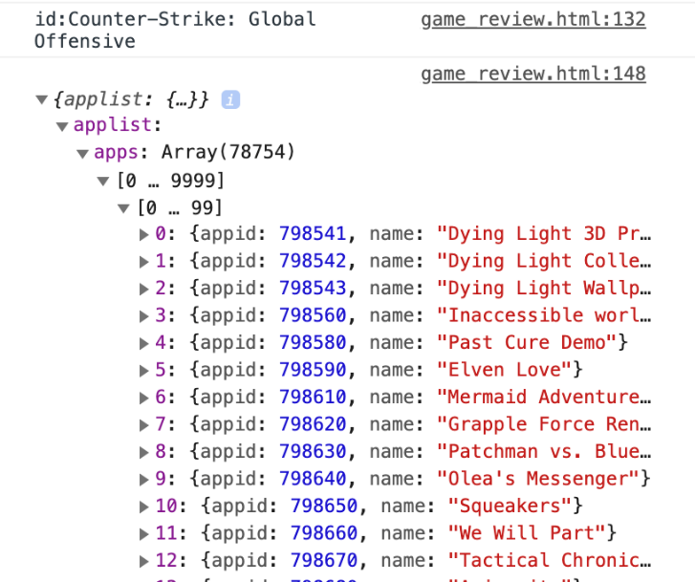

It will show the same result on the webpage as the image below.

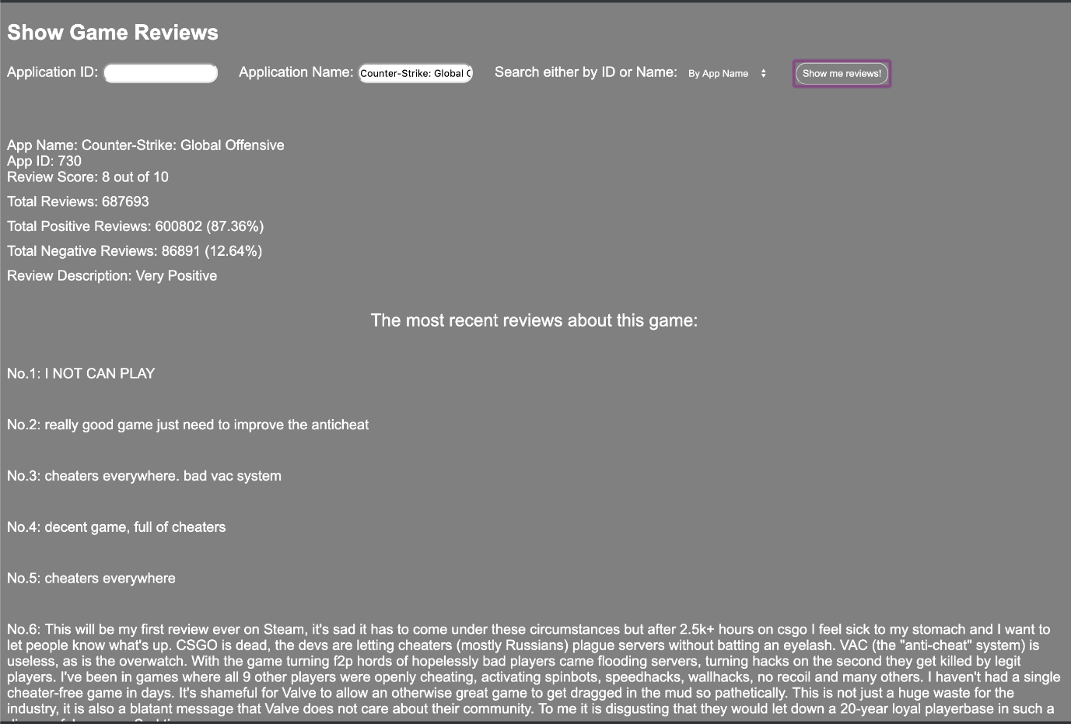

**Graph – Game Type vs Time Played:**

For first graph part, we design the function to show all the game types that user played. First we should login steam, then we should go to personal information to get your id for using this function.



The number which is in the middle of this URL is the key to use our function. After we get this user ID number, we input this ID number on the top of this page. Then we can get a graph for “game type vs time played”.

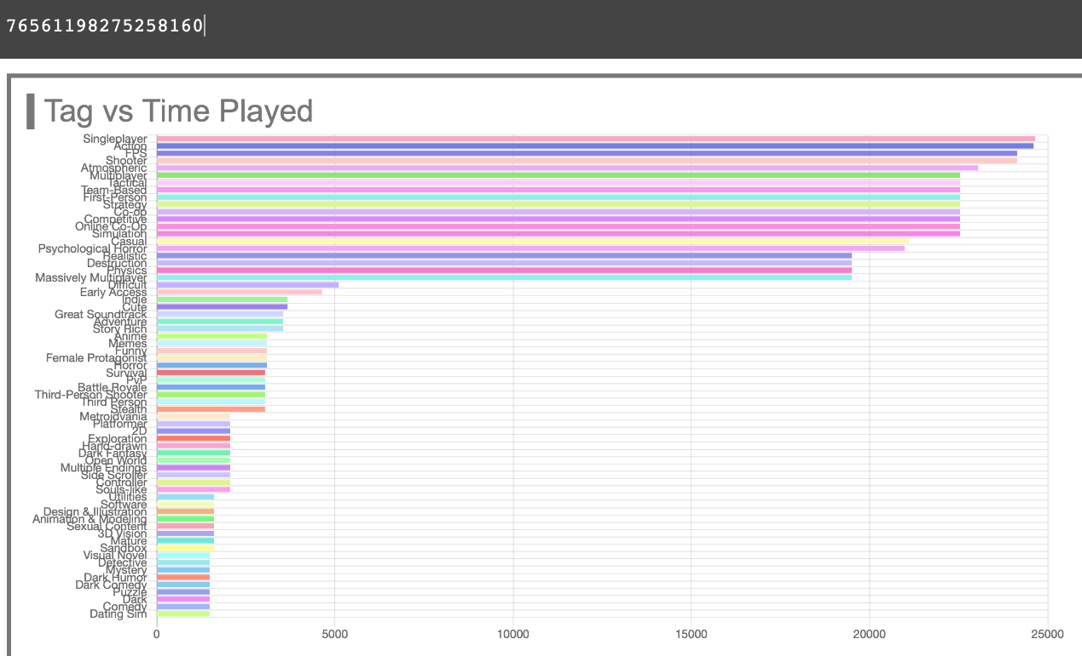

In this graph, our page will should all the types of games that user which we input played. For example, the user “76561198275258160” have played total 66 types of game. As we can see, this user spends a lot of time on game types “Single player”, “Action”, “FPS”, and “Shooter”. He spends nearly 25000 minutes on each of “Single player”, “Action”, “FPS”, “Multiplayer” and “Shooter”. We can also know that which kinds of game that this user hardly plays like “Sand box”, “Comedy”.



When you want to see the detail time that how much time this user spent on this game type. You just need to put mouse on the bar of this game type, you will see the detail time on the right.

Graph – Games/Time Played

In this page, after we input user ID, there is another graph. The use of this graph is to show games sort by spending time.

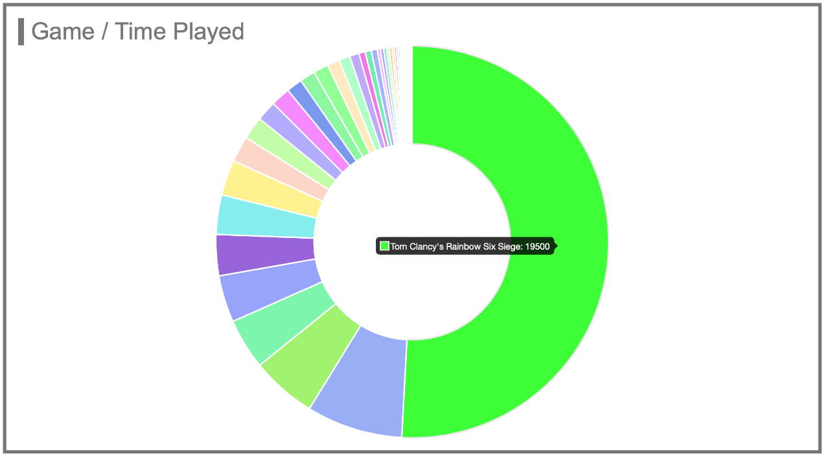

As we can see, this user spent half of time that use to play game playing “Tom Clancy’s Rainbow Six Siege”. And he spent 19500 minutes on this game. You have to put your mouse on the areas to show the name of the game and the time this user spent on this game.

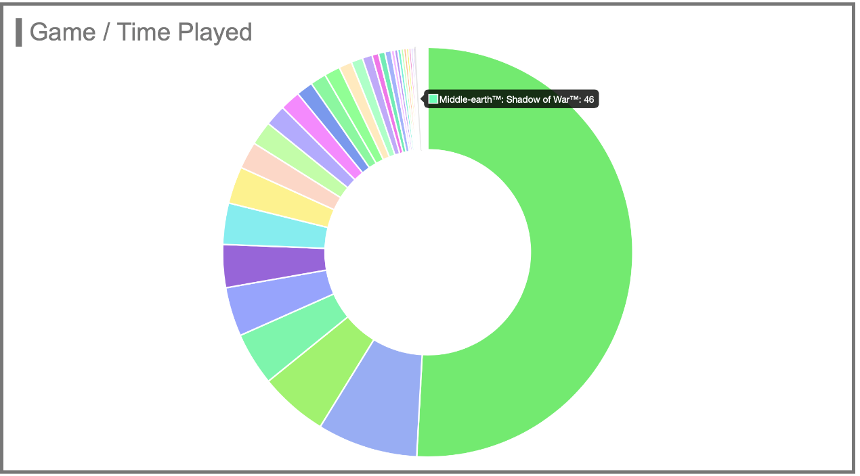

It’s hard to see the areas of the games which this user spent least time on. For instance, this user only spent 46 minutes on “Middle-earth: Shadow of War.”

Graph – Data Analysis

By viewing these two graphs, we can know that which game type and game that this user like most. Moreover, we can use these two graphs to see which friends of this user are his close friend, which means usually play games with this user.

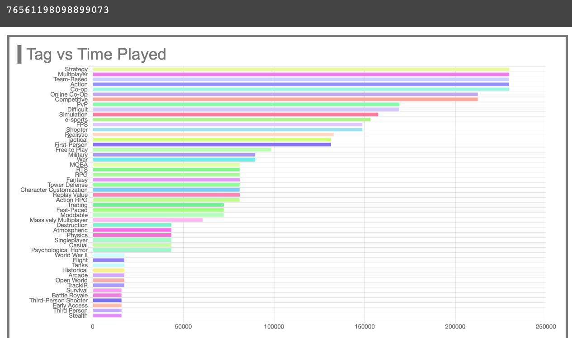

We input another user who is the friend of the user before. We can see he also spend a lot of time on “Multiplayer”, “Action”, “FPS”. Then we also should see the second graph.

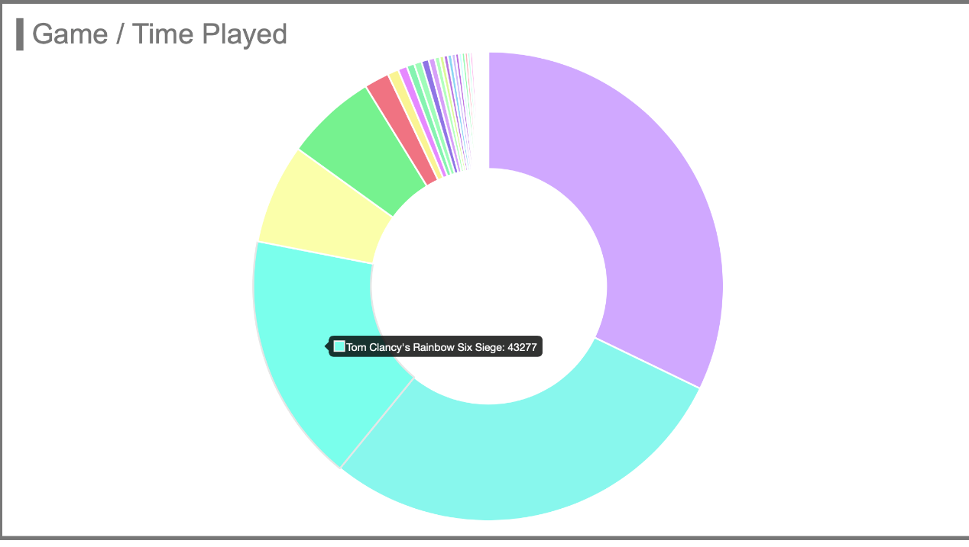

Although the user before didn’t played the two of this user’s two favorite game. We can see that both of them like to play “Tom Clancy’s Rainbow Six Siege”. And this user spent 43277 minutes on this game which is a lot. We can know that these two users may played this game together for long time.

Then let we input another friend of first user.

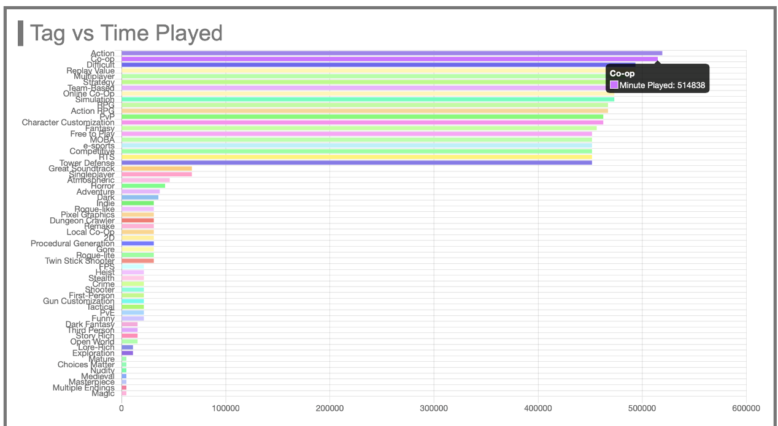

We can find that his favorite game type is “Action”, “Co-op”, “Multiplayer”, which is similar to first user. However, when we check second graph.

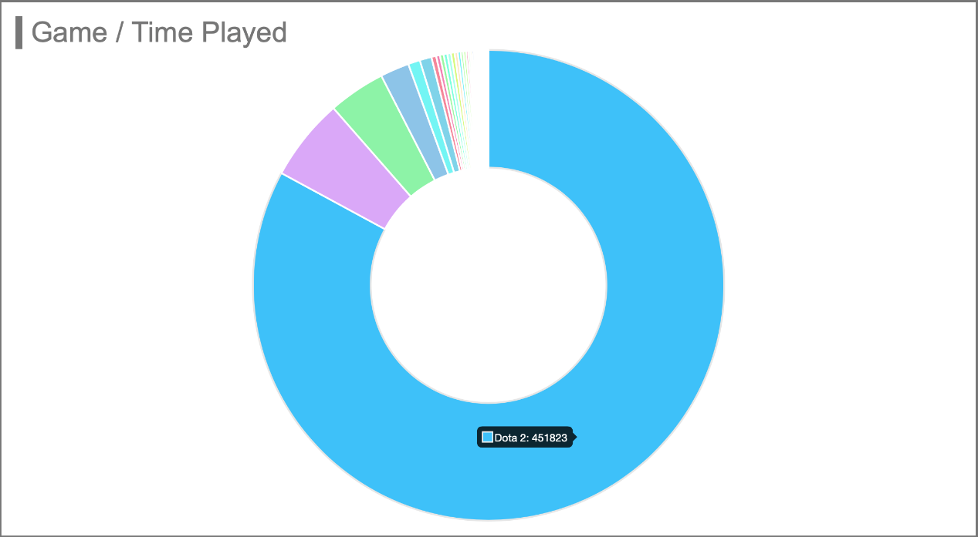

We can find that he spends most of gaming time on “Dota2”, which shows that he hardly play with first user.

**Technique Details:**

Core components:

Notice that all the API wrapping components mentioned below have been proxied through our server, as most of the Steam APIs did not set CROS related headers correctly, and thus we can't use it in the browser unless we disable security feature in our browser, which we don't want users to do.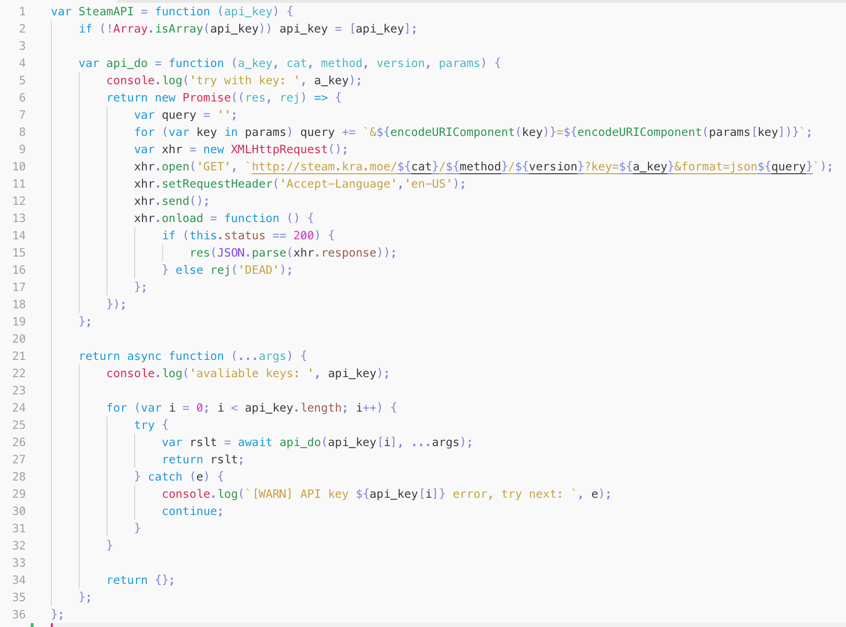

When you construct a SteamAPI object, you can supply an array of keys or a single string of the key. If an array is supplied, SteamAPI will enable the fallback feature. The SteamAPI instance takes four parameters, API Catagory, API method, API call payload. The SteamAPI instance is an async function, and thus a Promise will be returned. User need to either use it in an async function and do await or use Promise.then.

Steam API wrapper: This is the core API wrapper for steam. This allows API calls to base Steam Web API functions (api.steampowered.com). This API wrapper allows the user to provide multiple API keys and has a fallback mechanism that automatically fallback to next available API key if one of them failed. This is the base of many higher-level functions such as getProfile, getReviews, getOwnedGames, UserNameReslvoe, etc.

Store API wrapper: Store API is an API that runs on a separate hostname (store.steampowered.com). This API does not require an API key and provide basic information about the game. (e.g., Name, AppID, Description, DLCs, System Requirements, etc.)

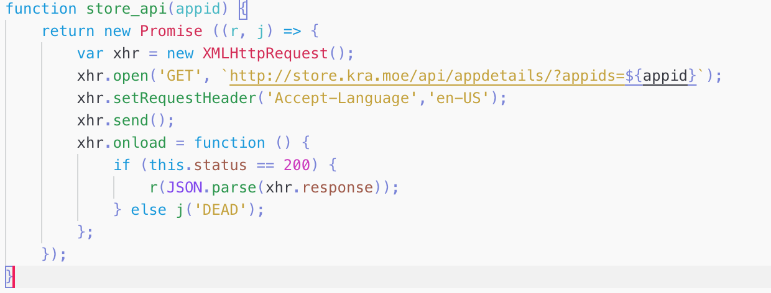

StoreAPI is not an async function, but it returns a new Promise. So we can use it the same way as SteamAPI instance (i.e., do await, or Promise.then) Since store API does not require an API key, the design is much more straightforward. We just make an XHR to the API and resolve if we got API responses, and reject otherwise.

The two wrappers above were implemented with Restful API. There is some other information that wasn't available through API calls.

**Conclusion:**

This project can help people quickly get user information and his friends’ information。 Moreover, it can let people have better understanding of a user’s gaming habit and certain game’s status and get game recommendation he/she may like based on his preference and his/her friends’ preference. By offering those recommendation, it will help steam user improve the user experience.